Freeform Organic Shapes
# Source: AI Source: Provided by: [Data Path: Persons Table -> ID Column: 1, Name_En Column: Motasem Essam] -> From: [ChatGPT] on [7/25/2026]
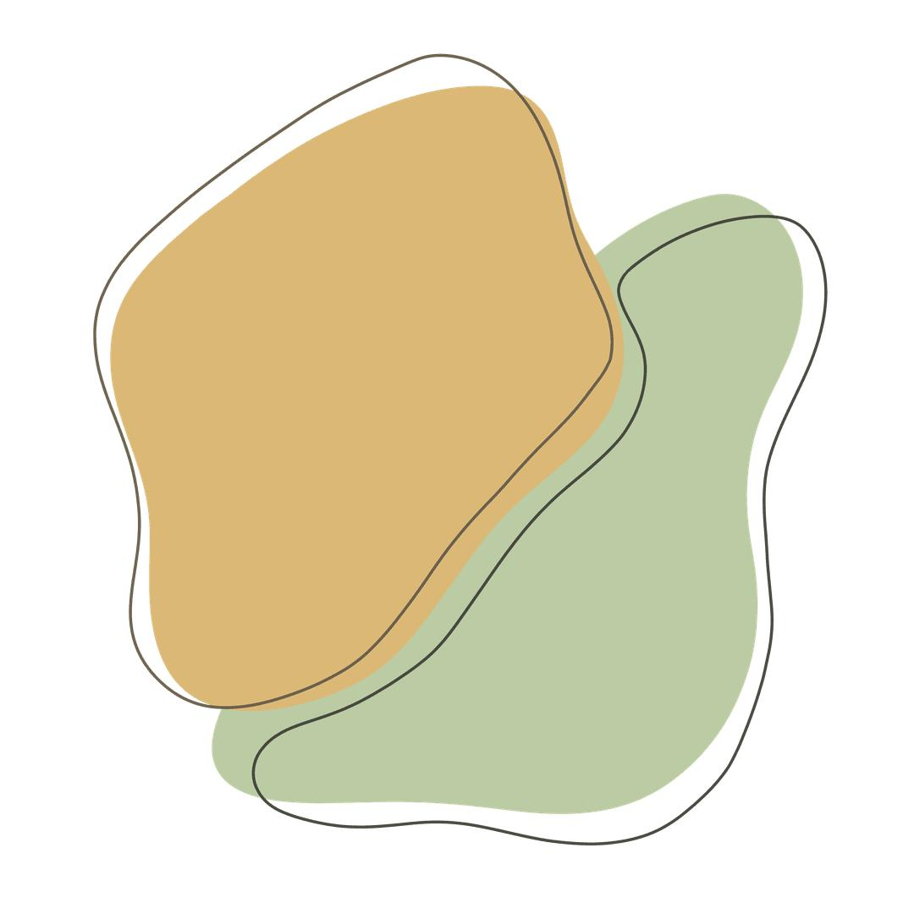
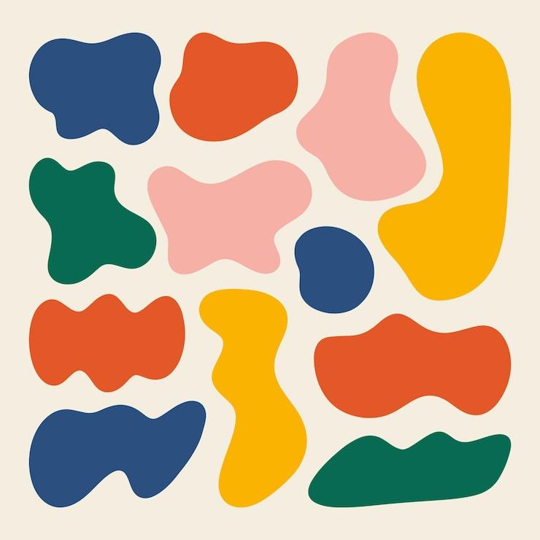
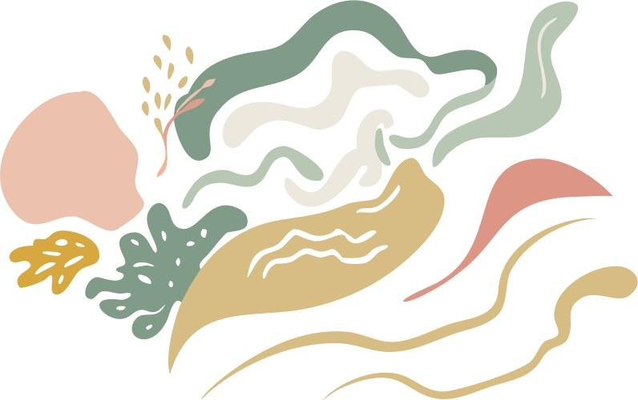
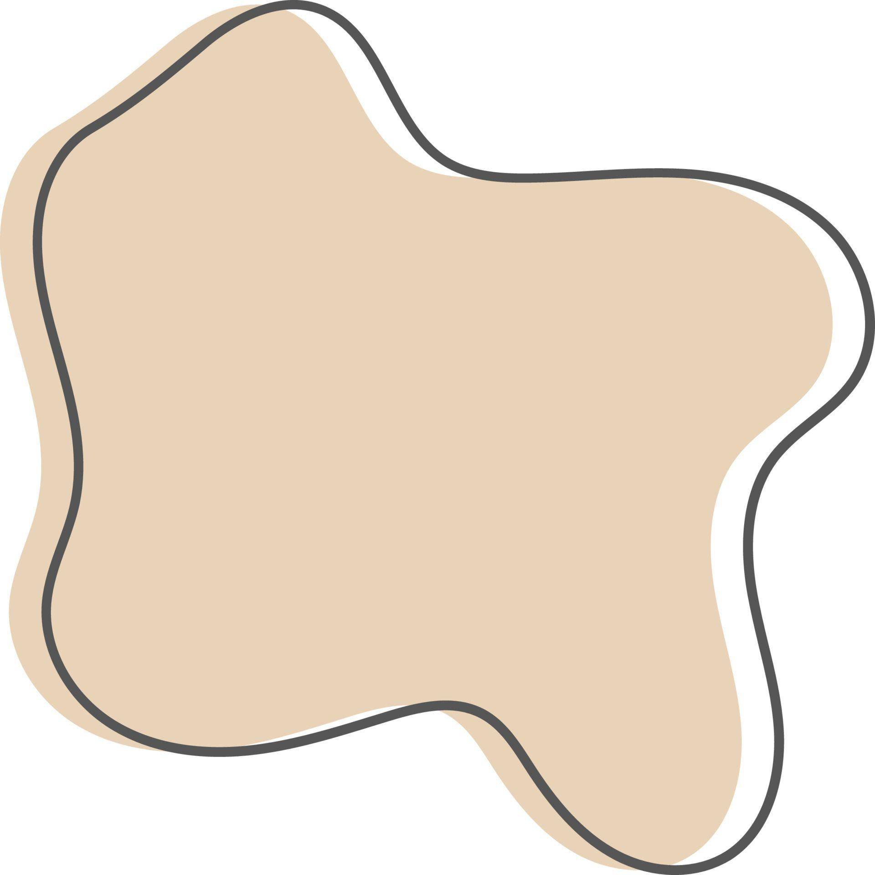
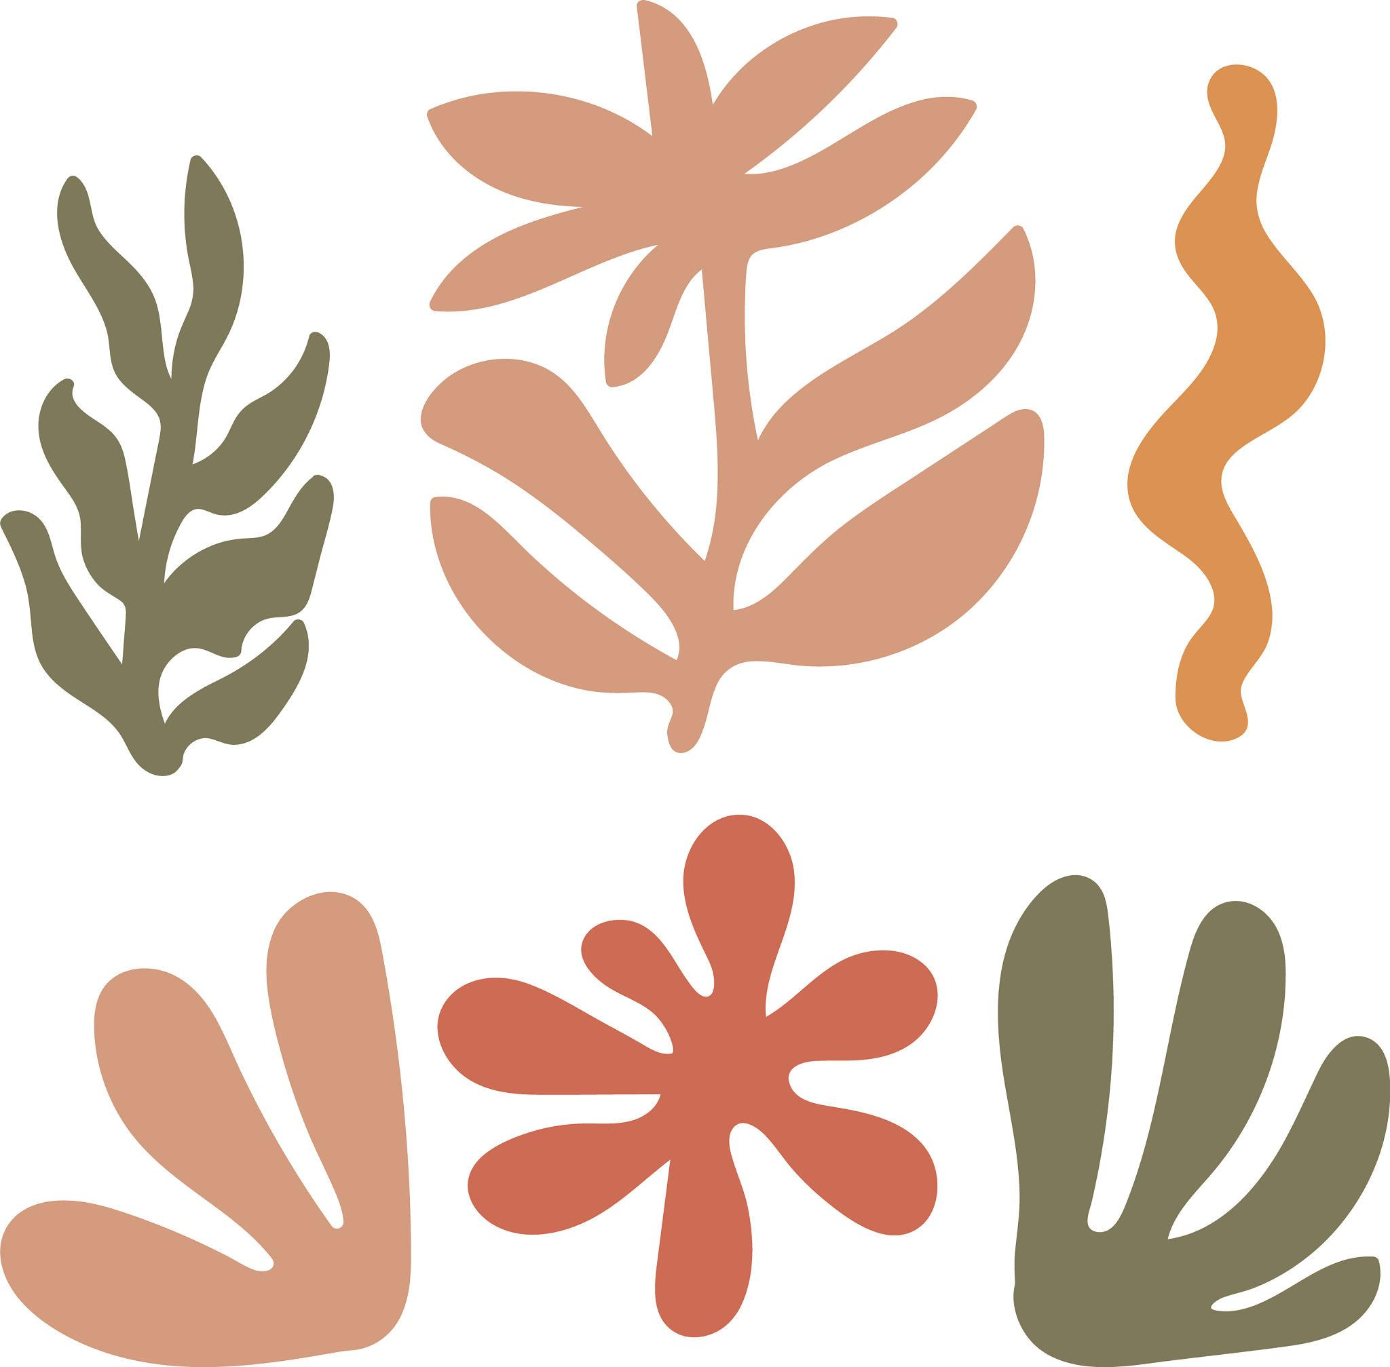
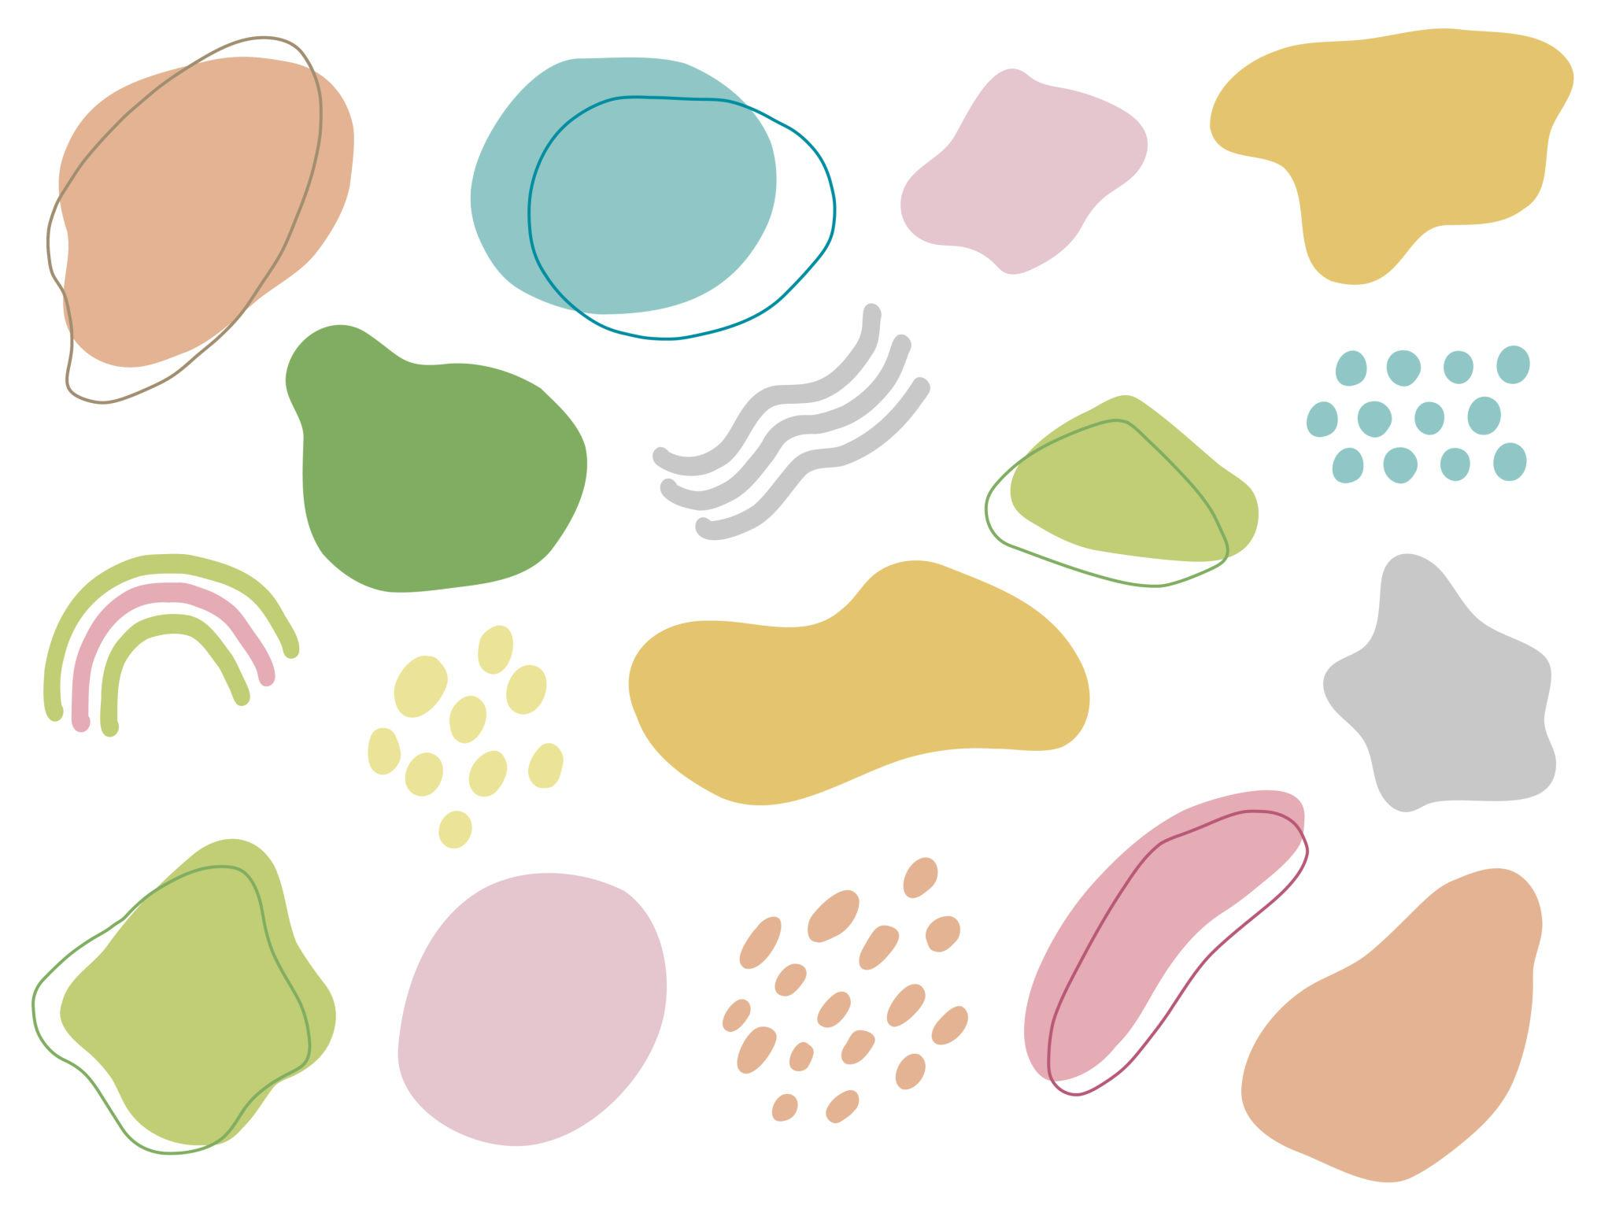

Definition
# Source: AI Source: Provided by: [Data Path: Persons Table -> ID Column: 1, Name_En Column: Motasem Essam] -> From: [ChatGPT] on [7/25/2026]
Freeform Organic Shapes are freeform shapes that have irregular, natural, flowing, or nature-inspired forms without following a fixed geometric structure or standard mathematical shape.
They typically contain:
- Smooth or irregular curves
- Uneven boundaries
- Non-uniform proportions
- Natural-looking forms
- Flexible or flowing contours
The term combines two characteristics:
Freeform → no fixed standard geometric structure
Organic → natural, irregular, or flowing appearance

Fundamental Concept
# Source: AI Source: Provided by: [Data Path: Persons Table -> ID Column: 1, Name_En Column: Motasem Essam] -> From: [ChatGPT] on [7/25/2026]
A Freeform Organic Shape is primarily defined by its overall visual and structural character, rather than by a specific mathematical construction.
For example, a shape may resemble:
- A leaf
- A cloud
- A puddle
- A pebble
- A blob
- A natural organism
- A plant form
These shapes may have mathematical descriptions, but they are not normally defined by simple standard geometric rules such as those defining a circle, square, or regular polygon.

Main Characteristics
# Source: AI Source: Provided by: [Data Path: Persons Table -> ID Column: 1, Name_En Column: Motasem Essam] -> From: [ChatGPT] on [7/25/2026]
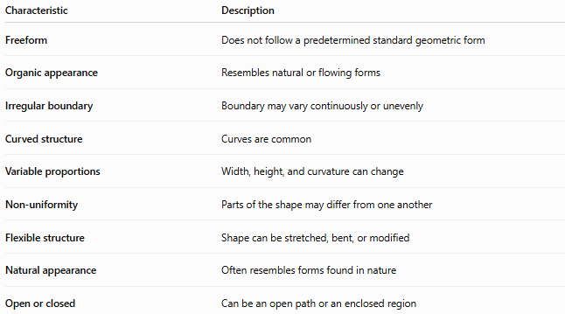
Characteristic | Description
Freeform | Does not follow a predetermined standard geometric form
Organic appearance | Resembles natural or flowing forms
Irregular boundary | Boundary may vary continuously or unevenly
Curved structure | Curves are common
Variable proportions | Width, height, and curvature can change
Non-uniformity | Parts of the shape may differ from one another
Flexible structure | Shape can be stretched, bent, or modified
Natural appearance | Often resembles forms found in nature
Open or closed | Can be an open path or an enclosed region

Basic Structure
# Source: AI Source: Provided by: [Data Path: Persons Table -> ID Column: 1, Name_En Column: Motasem Essam] -> From: [ChatGPT] on [7/25/2026]
A Freeform Organic Shape can be viewed as a combination of flowing boundaries:
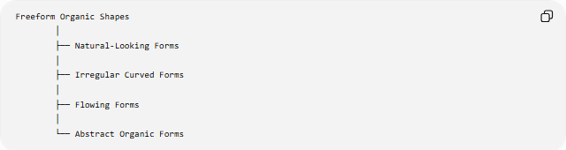
Freeform Organic Shapes
│
├── Natural-Looking Forms
│
├── Irregular Curved Forms
│
├── Flowing Forms
│
└── Abstract Organic Forms
Most closed Freeform Organic Shapes have a continuous boundary enclosing a region.
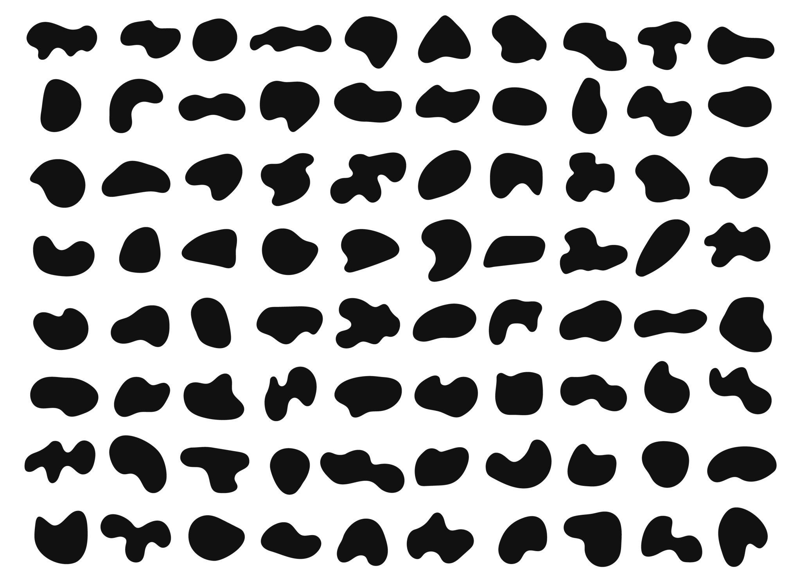
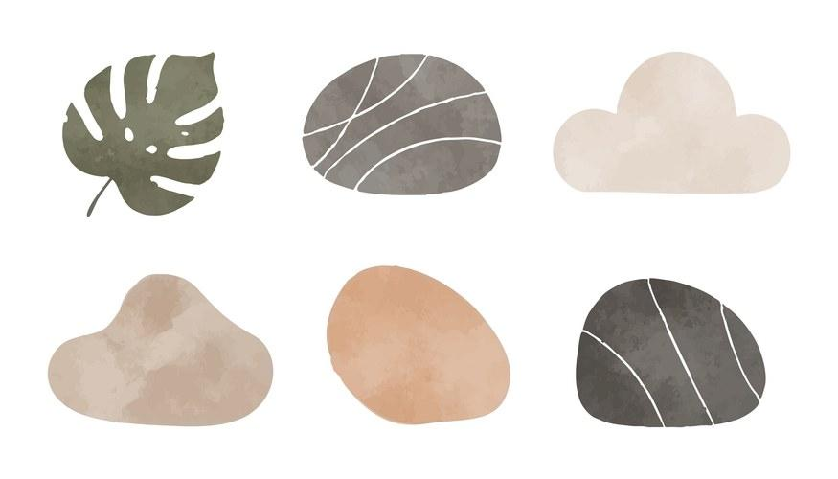
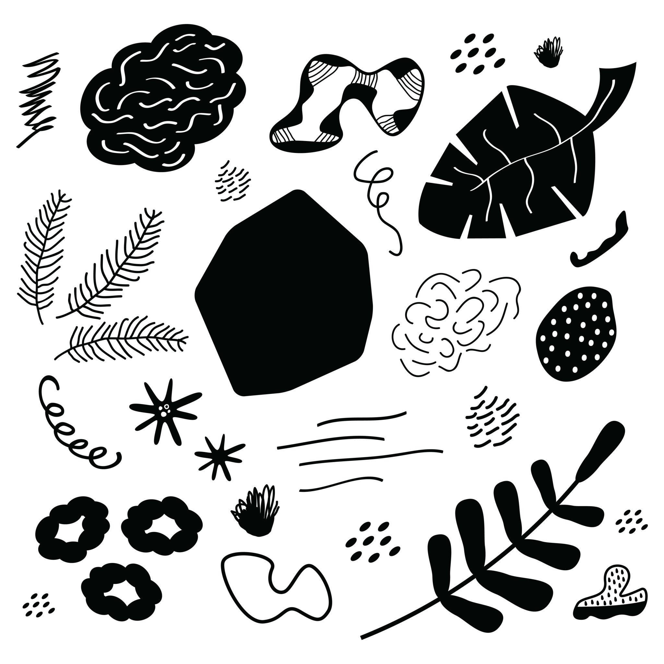
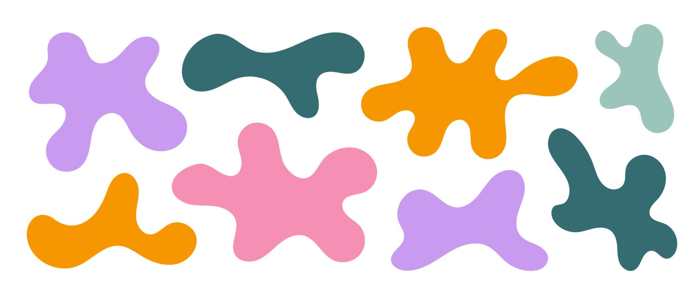
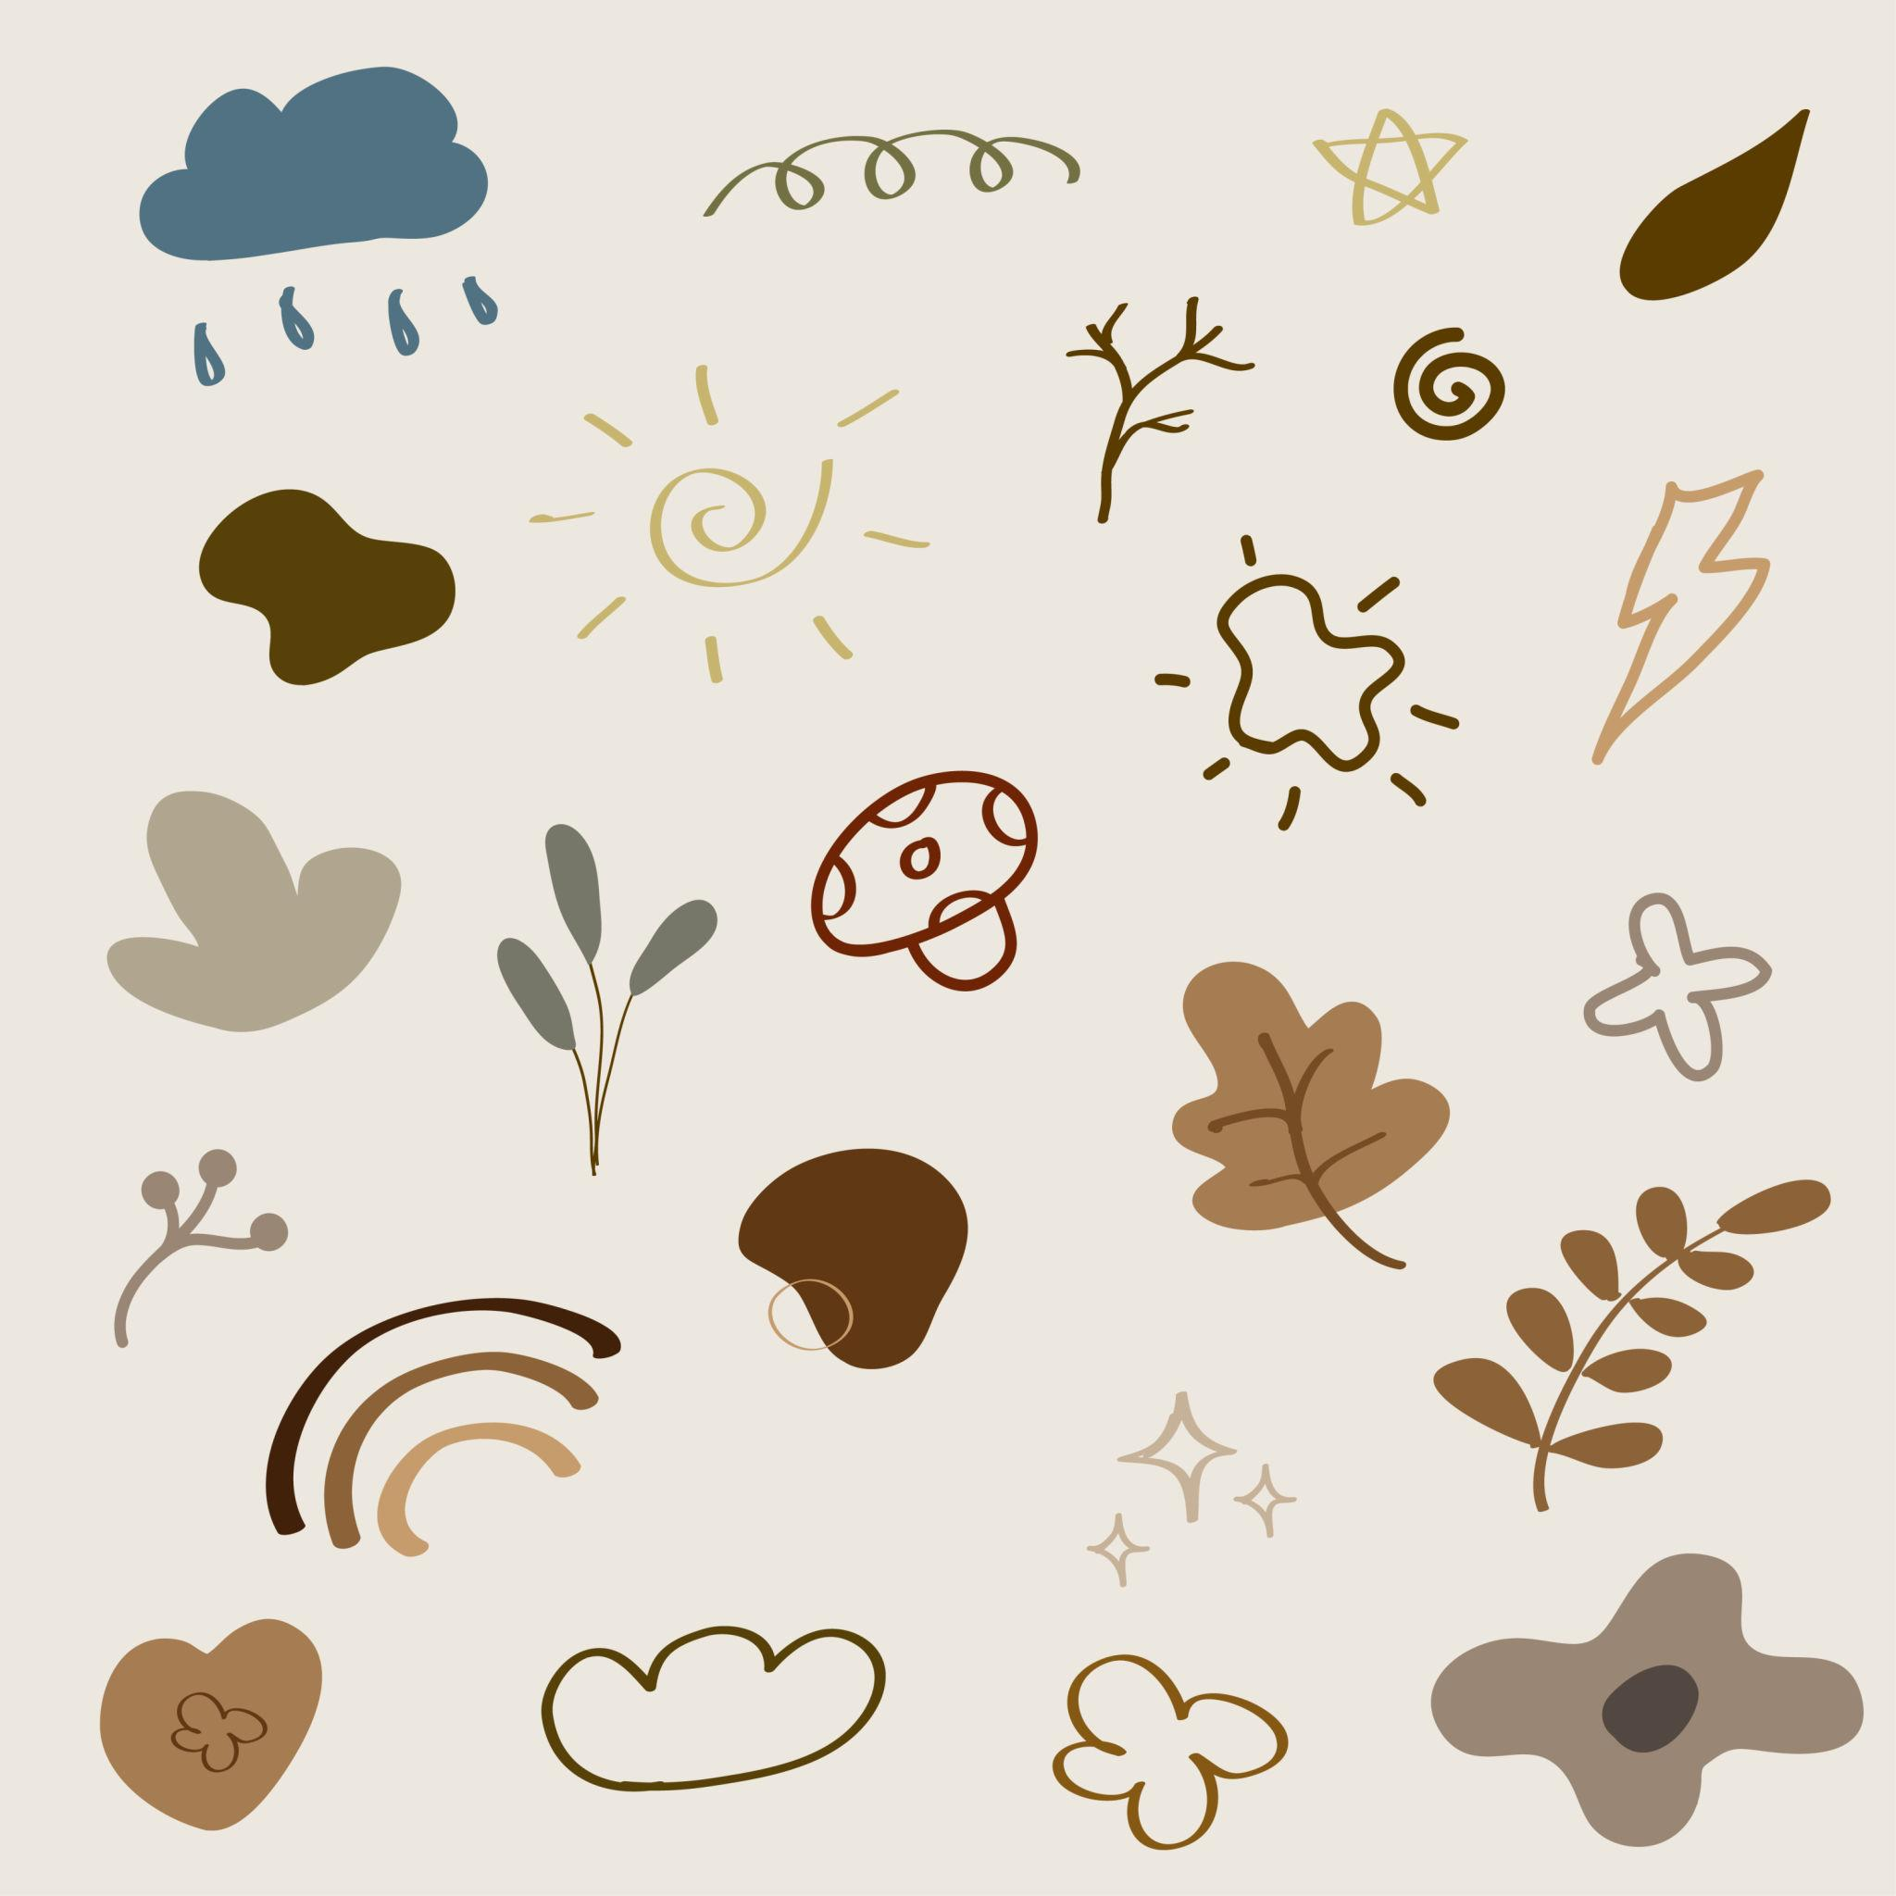
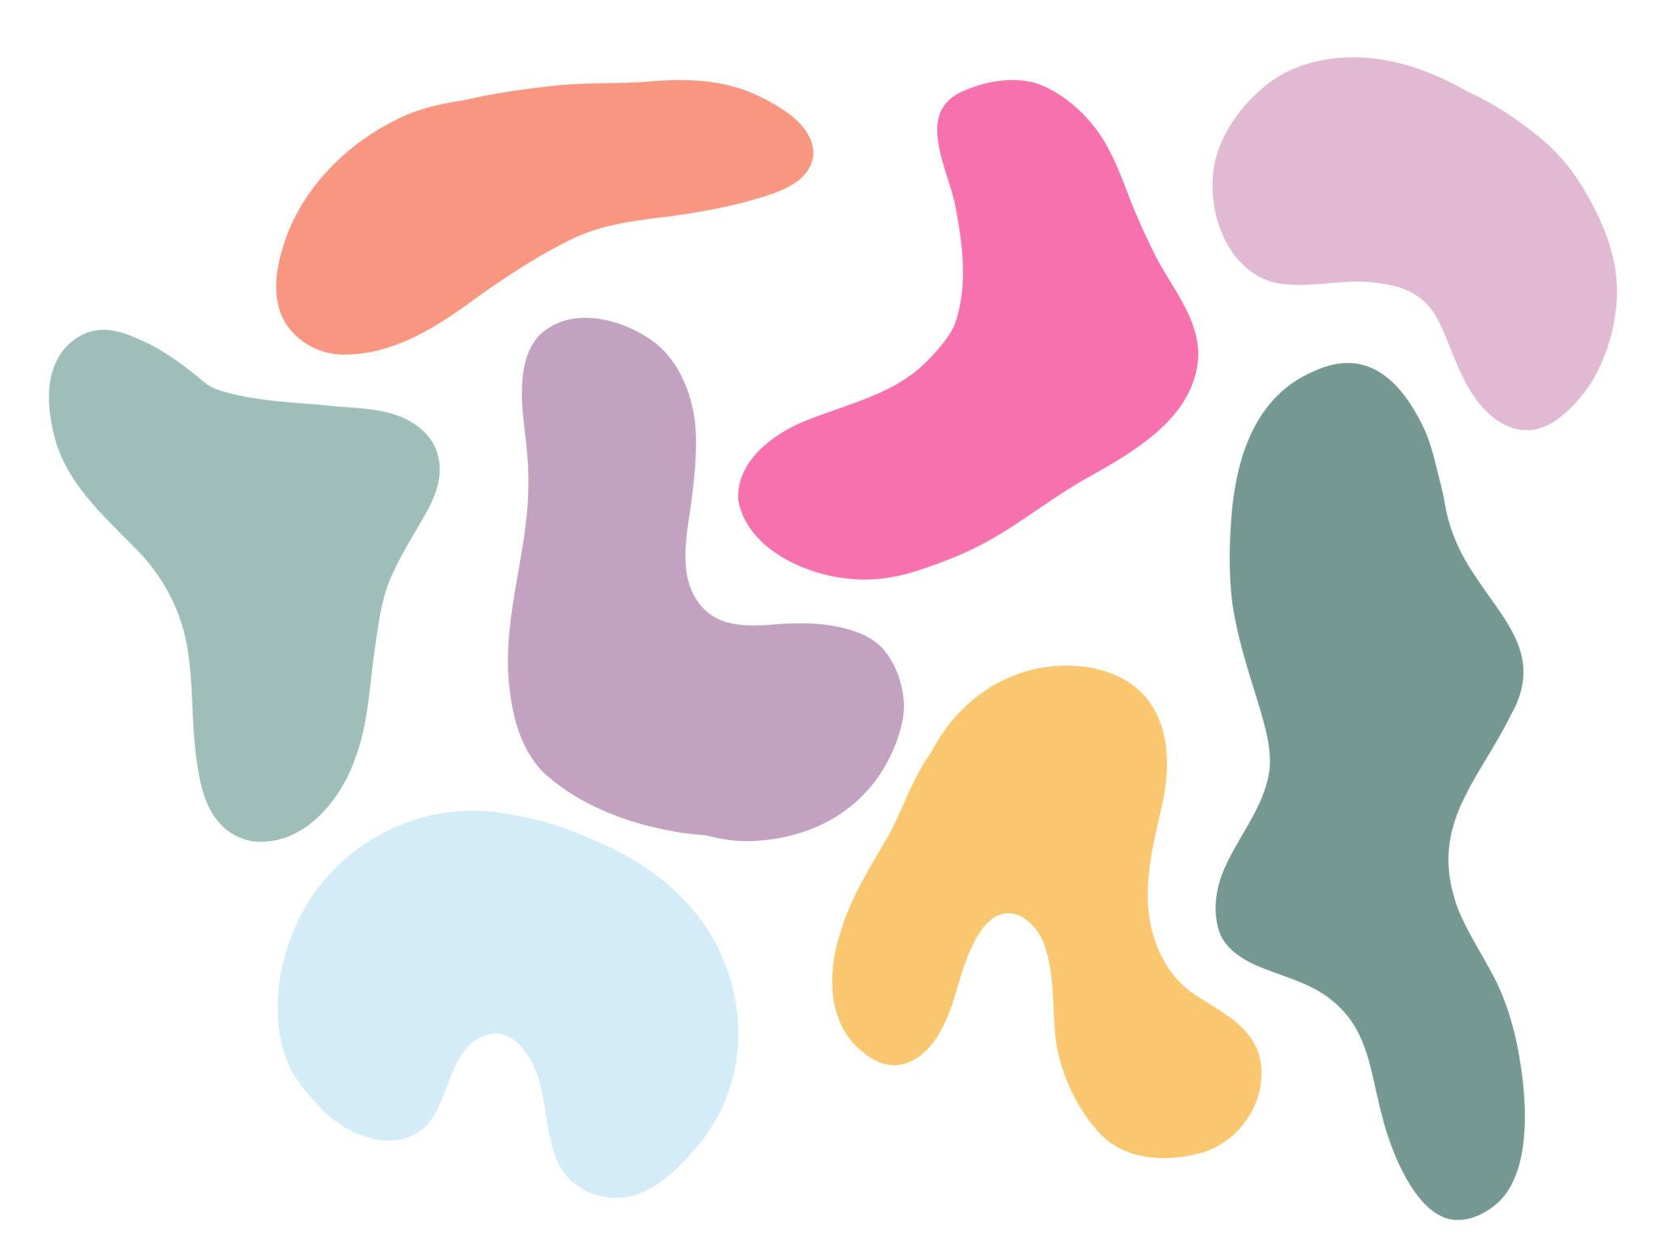

Types of Freeform Organic Shapes
# Source: AI Source: Provided by: [Data Path: Persons Table -> ID Column: 1, Name_En Column: Motasem Essam] -> From: [ChatGPT] on [7/25/2026]
A useful descriptive classification is:
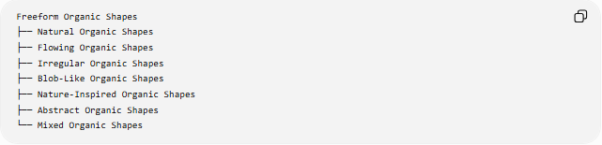
Freeform Organic Shapes
├── Natural Organic Shapes
├── Flowing Organic Shapes
├── Irregular Organic Shapes
├── Blob-Like Organic Shapes
├── Nature-Inspired Organic Shapes
├── Abstract Organic Shapes
└── Mixed Organic Shapes
These categories can overlap because Freeform Organic Shapes are descriptive rather than a strict mathematical classification.

1-Natural Organic Shapes
# Source: AI Source: Provided by: [Data Path: Persons Table -> ID Column: 1, Name_En Column: Motasem Essam] -> From: [ChatGPT] on [7/25/2026]
Shapes that resemble forms naturally occurring in the environment.
Examples include forms resembling:
- Leaves
- Stones
- Clouds
- Water pools
- Plants
- Animal forms
Their boundaries generally do not follow regular geometric patterns.

2-Flowing Organic Shapes
# Source: AI Source: Provided by: [Data Path: Persons Table -> ID Column: 1, Name_En Column: Motasem Essam] -> From: [ChatGPT] on [7/25/2026]
Shapes characterized by smooth, continuous, flowing contours.
Their boundaries may contain:
- Broad curves
- Narrow curves
- Gradual direction changes
- Smooth transitions
They are often used to create a sense of movement or softness.

3-Irregular Organic Shapes
# Source: AI Source: Provided by: [Data Path: Persons Table -> ID Column: 1, Name_En Column: Motasem Essam] -> From: [ChatGPT] on [7/25/2026]
Shapes with uneven or non-uniform forms.
Different portions may have different:
- Widths
- Curvatures
- Lengths
- Proportions
- Directions
An irregular organic shape does not need to have a repeating pattern.

4-Blob-Like Organic Shapes
# Source: AI Source: Provided by: [Data Path: Persons Table -> ID Column: 1, Name_En Column: Motasem Essam] -> From: [ChatGPT] on [7/25/2026]
Rounded, irregular forms with soft boundaries.
Examples include shapes resembling:
- Droplets
- Puddles
- Clouds
- Soft blobs
- Rounded natural masses
A blob-like shape may be mathematically represented by a closed curve even though it does not correspond to a standard geometric shape.

5-Nature-Inspired Organic Shapes
# Source: AI Source: Provided by: [Data Path: Persons Table -> ID Column: 1, Name_En Column: Motasem Essam] -> From: [ChatGPT] on [7/25/2026]
Designed shapes that imitate or are inspired by natural forms.
Examples include shapes inspired by:
- Leaves
- Flowers
- Waves
- Branches
- Stones
- Clouds
- Biological forms
The important characteristic is the natural visual influence, rather than an exact mathematical resemblance.

6-Abstract Organic Shapes
# Source: AI Source: Provided by: [Data Path: Persons Table -> ID Column: 1, Name_En Column: Motasem Essam] -> From: [ChatGPT] on [7/25/2026]
Freeform shapes that have an organic appearance but do not specifically represent a recognizable natural object.
For example, an abstract shape may have:
- Smooth curves
- Uneven bulges
- Irregular indentations
- Asymmetric proportions
It may look natural without representing a particular object.

7-Mixed Organic Shapes
# Source: AI Source: Provided by: [Data Path: Persons Table -> ID Column: 1, Name_En Column: Motasem Essam] -> From: [ChatGPT] on [7/25/2026]
Shapes that combine several organic characteristics.
For example:
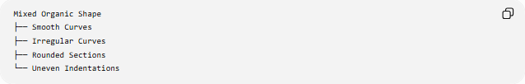
Mixed Organic Shape
├── Smooth Curves
├── Irregular Curves
├── Rounded Sections
└── Uneven Indentations
A mixed organic shape may also combine curved and straight portions while maintaining an overall organic appearance.

Open and Closed Freeform Organic Shapes
# Source: AI Source: Provided by: [Data Path: Persons Table -> ID Column: 1, Name_En Column: Motasem Essam] -> From: [ChatGPT] on [7/25/2026]
Freeform Organic Shapes can also be classified according to whether their boundary is open or closed.

Open Freeform Organic Shape
# Source: AI Source: Provided by: [Data Path: Persons Table -> ID Column: 1, Name_En Column: Motasem Essam] -> From: [ChatGPT] on [7/25/2026]
An open organic form has two endpoints and does not enclose a region.
For example, a flowing organic line may resemble a branch or vine.
Mathematically, it can be represented parametrically as:
$$r\left(t\right)=\left(x , \left(t\right)y\left(t\right)\right)$$
with:
$$r\left(a\right)≠r\left(b\right)$$

Closed Freeform Organic Shape
# Source: AI Source: Provided by: [Data Path: Persons Table -> ID Column: 1, Name_En Column: Motasem Essam] -> From: [ChatGPT] on [7/25/2026]
A closed organic shape has no endpoints and encloses a region.
Its parametric representation satisfies:
$$r\left(a\right)=r\left(b\right)$$
Examples include shapes resembling:
- Leaves
- Puddles
- Clouds
- Pebbles
- Organic blobs

Mathematical Representation
# Source: AI Source: Provided by: [Data Path: Persons Table -> ID Column: 1, Name_En Column: Motasem Essam] -> From: [ChatGPT] on [7/25/2026]
Although Freeform Organic Shapes are primarily descriptive, they can be represented mathematically using curves.
Parametric representation
$$r\left(t\right)=\left(x , \left(t\right)y\left(t\right)\right)$$
where $x\left(t\right)$and $y\left(t\right)$define the position of a point on the boundary.
Polar representation
Some organic forms can be represented using:
$$r=f\left(θ\right)$$
This allows the distance from a center to vary with direction.
For example:
$$r\left(θ\right)=R+Asin⁡\left(nθ\right)$$
can produce a varying, organic-like closed curve.

Curvature
# Source: AI Source: Provided by: [Data Path: Persons Table -> ID Column: 1, Name_En Column: Motasem Essam] -> From: [ChatGPT] on [7/25/2026]
The curvature of a smooth curve describes how strongly its direction changes.
For a curve:
$$y=f\left(x\right)$$
the curvature is:
$$κ=\frac{∣f^{''}\left(x\right)∣}{{\left(1+{\left[f^{'}\left(x\right)\right]}^{2}\right)}^{3/2}}$$
A Freeform Organic Shape can have curvature that varies continuously along its boundary.
Unlike a circle, whose curvature is constant:
$$κ=\frac{1}{r}$$
an organic boundary may have different curvature values at different points.

Area and Boundary Length
# Source: AI Source: Provided by: [Data Path: Persons Table -> ID Column: 1, Name_En Column: Motasem Essam] -> From: [ChatGPT] on [7/25/2026]
For a closed smooth organic boundary, the enclosed area can be represented by:
$$A=\frac{1}{2}\oint{(}\left.x dy-y dx\right)$$
The boundary length is:
$$L=\int_{a}^{b}{\sqrt{{\left(\frac{dx}{dt}\right)}^{2}+{\left(\frac{dy}{dt}\right)}^{2}}} dt$$
These formulas can describe the geometry even when the shape itself is not a standard geometric figure.

Symmetry
# Source: AI Source: Provided by: [Data Path: Persons Table -> ID Column: 1, Name_En Column: Motasem Essam] -> From: [ChatGPT] on [7/25/2026]
Freeform Organic Shapes may be:
- Symmetric
- Asymmetric
- Partially symmetric
For example, a stylized leaf may have approximate bilateral symmetry, while a naturally shaped stone may have no obvious symmetry.
Symmetry is therefore not a defining requirement of an organic shape.

Freeform Organic Shapes vs Other Shapes
# Source: AI Source: Provided by: [Data Path: Persons Table -> ID Column: 1, Name_En Column: Motasem Essam] -> From: [ChatGPT] on [7/25/2026]
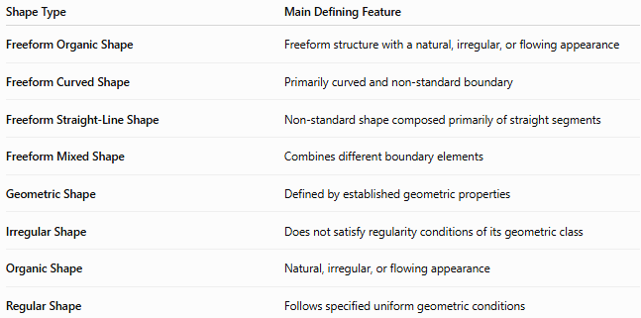
Shape Type | Main Defining Feature
Freeform Organic Shape | Freeform structure with a natural, irregular, or flowing appearance
Freeform Curved Shape | Primarily curved and non-standard boundary
Freeform Straight-Line Shape | Non-standard shape composed primarily of straight segments
Freeform Mixed Shape | Combines different boundary elements
Geometric Shape | Defined by established geometric properties
Irregular Shape | Does not satisfy regularity conditions of its geometric class
Organic Shape | Natural, irregular, or flowing appearance
Regular Shape | Follows specified uniform geometric conditions
Important distinction
Freeform Organic Shape and Organic Shape are closely related but not identical terms.
- Organic Shape emphasizes the natural or flowing character.
- Freeform Organic Shape additionally emphasizes the absence of a fixed geometric structure.

Freeform Organic Shapes vs Irregular Shapes
# Source: AI Source: Provided by: [Data Path: Persons Table -> ID Column: 1, Name_En Column: Motasem Essam] -> From: [ChatGPT] on [7/25/2026]
These terms should not be treated as exact synonyms.
An irregular polygon can have unequal sides and angles while remaining a clearly defined polygon.
For example:
$$\text{Irregular Pentagon}$$
is still a geometric polygon.
A Freeform Organic Shape, in contrast, may have a boundary that does not correspond to a standard polygonal structure at all.
Therefore:
Irregular describes lack of regularity, while freeform organic describes a non-standard form with an organic or natural appearance.

Freeform Organic Shapes vs Freeform Curved Shapes
# Source: AI Source: Provided by: [Data Path: Persons Table -> ID Column: 1, Name_En Column: Motasem Essam] -> From: [ChatGPT] on [7/25/2026]
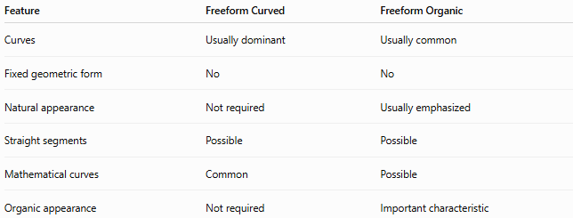
Feature | Freeform Curved | Freeform Organic
Curves | Usually dominant | Usually common
Fixed geometric form | No | No
Natural appearance | Not required | Usually emphasized
Straight segments | Possible | Possible
Mathematical curves | Common | Possible
Organic appearance | Not required | Important characteristic
A freeform curved shape does not have to look natural.
For example, an abstract mathematical curve may be freeform and curved without having an organic appearance.

Examples

Example 1 — Leaf-Like Form
# Source: AI Source: Provided by: [Data Path: Persons Table -> ID Column: 1, Name_En Column: Motasem Essam] -> From: [ChatGPT] on [7/25/2026]
A closed, curved, asymmetric or approximately symmetric shape resembling a leaf can be classified as a Freeform Organic Shape.

Example 2 — Cloud-Like Form
# Source: AI Source: Provided by: [Data Path: Persons Table -> ID Column: 1, Name_En Column: Motasem Essam] -> From: [ChatGPT] on [7/25/2026]
A shape consisting of several smooth rounded sections and indentations can represent a Freeform Organic Shape.

Example 3 — Pebble-Like Form
# Source: AI Source: Provided by: [Data Path: Persons Table -> ID Column: 1, Name_En Column: Motasem Essam] -> From: [ChatGPT] on [7/25/2026]
An irregular closed boundary with varying curvature can resemble a naturally formed pebble.

Example 4 — Abstract Organic Form
# Source: AI Source: Provided by: [Data Path: Persons Table -> ID Column: 1, Name_En Column: Motasem Essam] -> From: [ChatGPT] on [7/25/2026]
A designer may create an irregular flowing shape without intending it to represent any particular natural object.
It can still be classified as a Freeform Organic Shape because of its combination of:
- Freeform structure
- Irregularity
- Flowing boundary
- Organic appearance

Classification Summary
# Source: AI Source: Provided by: [Data Path: Persons Table -> ID Column: 1, Name_En Column: Motasem Essam] -> From: [ChatGPT] on [7/25/2026]
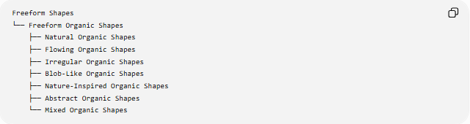
Freeform Shapes
└── Freeform Organic Shapes
├── Natural Organic Shapes
├── Flowing Organic Shapes
├── Irregular Organic Shapes
├── Blob-Like Organic Shapes
├── Nature-Inspired Organic Shapes
├── Abstract Organic Shapes
└── Mixed Organic Shapes
A structural classification can also be represented as:
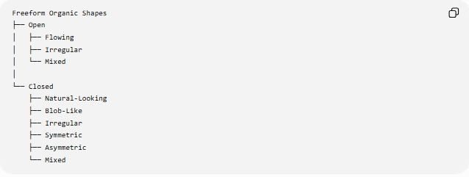
Freeform Organic Shapes
├── Open
│ ├── Flowing
│ ├── Irregular
│ └── Mixed
│
└── Closed
├── Natural-Looking
├── Blob-Like
├── Irregular
├── Symmetric
├── Asymmetric
└── Mixed
These classifications overlap rather than forming mutually exclusive categories.
For example, one shape can simultaneously be:
Closed + Freeform + Organic + Asymmetric + Nature-Inspired

Key Points
# Source: AI Source: Provided by: [Data Path: Persons Table -> ID Column: 1, Name_En Column: Motasem Essam] -> From: [ChatGPT] on [7/25/2026]
- Freeform Organic Shapes combine freeform structure with an organic, natural, irregular, or flowing appearance.
- They do not follow a fixed standard geometric form.
- Curves are common, but straight segments may also occur.
- They can be open or closed.
- Closed organic shapes can enclose measurable regions.
- They may be symmetric, asymmetric, or partially symmetric.
- Their boundaries can be modeled mathematically using parametric, polar, spline, or other curve representations.
- Organic describes the natural or flowing character.
- Freeform describes the absence of a predetermined geometric structure.
- Irregular and organic are related but are not synonymous.
- The classification is primarily descriptive, rather than a strict universal mathematical taxonomy.

Conclusion
# Source: AI Source: Provided by: [Data Path: Persons Table -> ID Column: 1, Name_En Column: Motasem Essam] -> From: [ChatGPT] on [7/25/2026]
A Freeform Organic Shape is a non-standard shape characterized by a natural, irregular, flowing, or nature-inspired form. It provides a bridge between geometric representation and organic visual structure, allowing shapes to have measurable mathematical boundaries while avoiding the rigid forms of standard geometric figures.

